Host discovery
The command is use toperform a discovery scan. In a discovery scan, the scanning host sends an ICMP echo request (ping)
nmap -sn 10.6.6.0/24

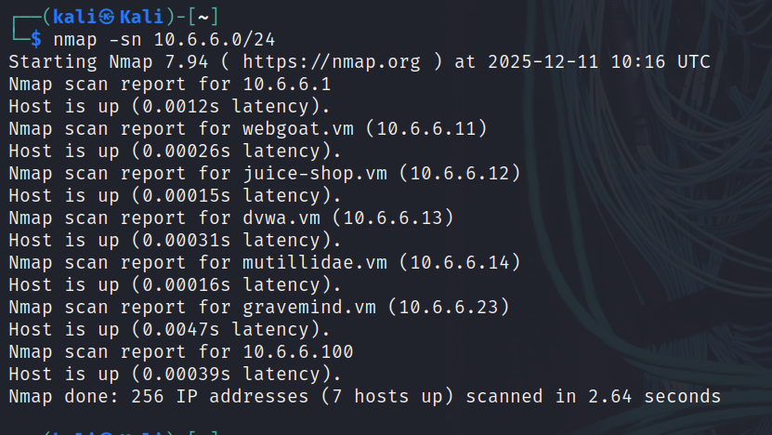
Output:

Obtain additional information about the host and services
You can use -v, -p, and -sV to find additional information about the services running on the open ports.

Operating System Discovery
The -O option can be used to further determine information about the operating system running on the target host.

sudo nmap -O 10.6.6.23

Some Nmap options require additional permissions and must be run as root or using the sudo command. To find operating system information on the target host, use the nmap -O command. Enter the password of kali when prompted.

Output:

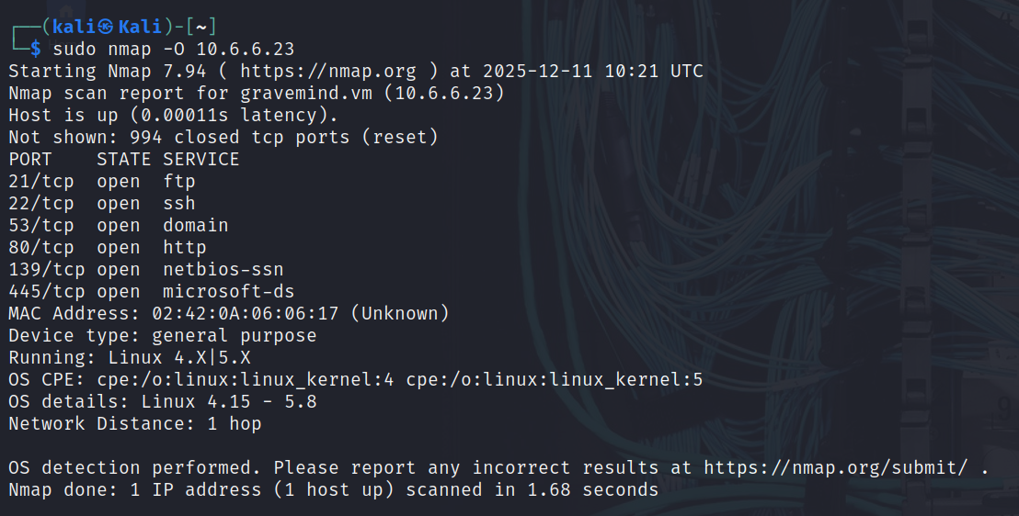

Find more information on these ports using the -A and -p command options. The -A option executes several functions including running the default scripts. Specify more than one port to scan by listing them separately with a comma between them.

nmap -A -p139,445 10.6.6.23

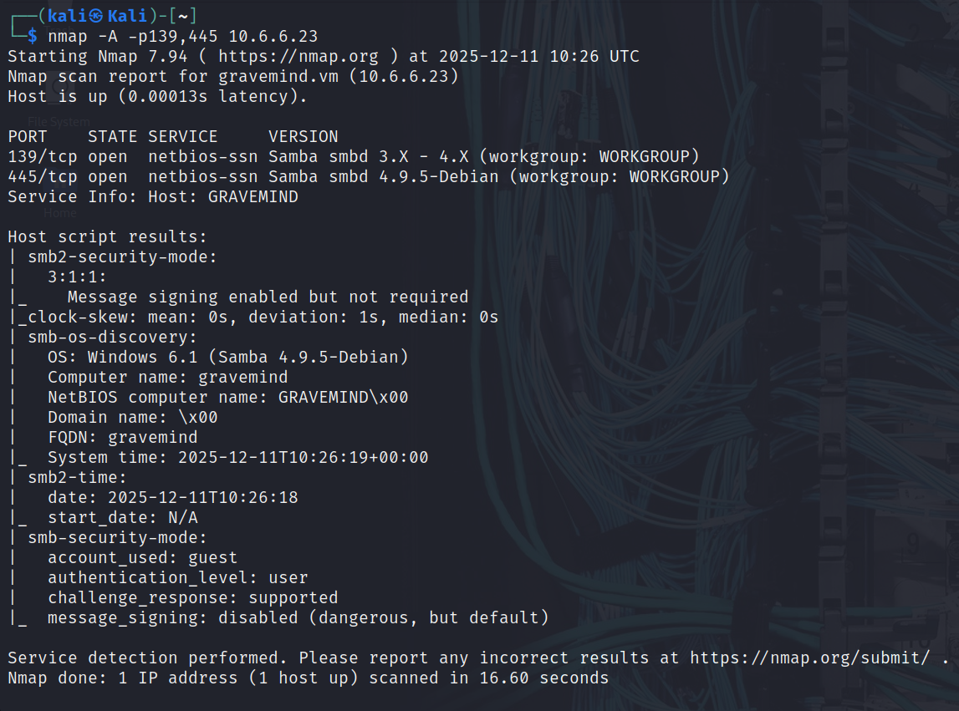
Output

SMB Services with Scripts
The Server Message Block (SMB) protocol is a network file sharing protocol supported on Windows computers and by SAMBA on Linux. SMB enables applications to read and write files or request services over a network. Open public shares or shared devices such as print servers on a network, can be accessed through SMB.

Nmap contains the powerful Nmap Scripting Engine (NSE), which enables the programming of various Nmap options and conditional actions to be taken as a result of the responses. NSE has built-in scripts that enumerate users, groups, and network shares. One of the more commonly used scripts for SMB discovery is the smb-enum-users.nse script. Use the Nmap NSE script with the command:

nmap --script smb-enum-users.nse -p139,445 10.6.6.23

Output
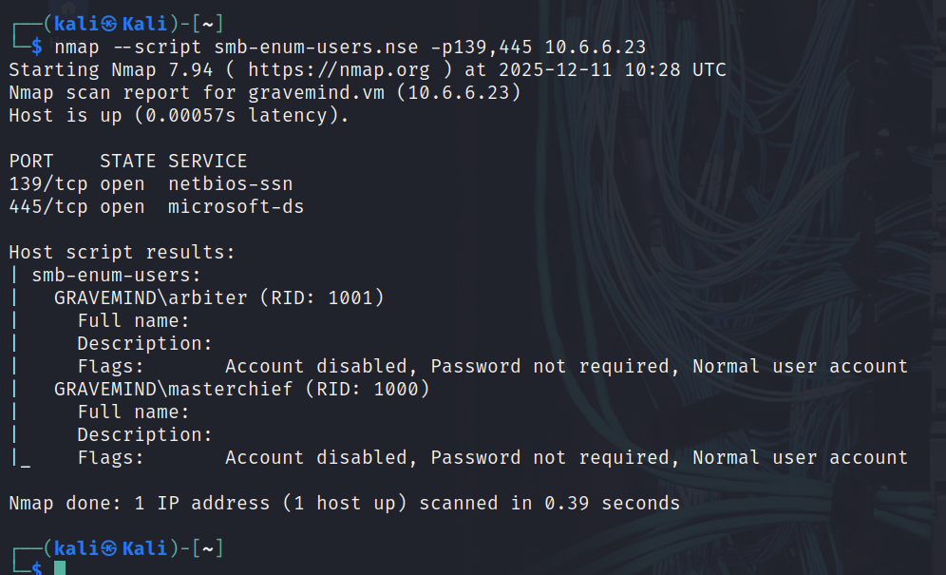

You can enumerate the network shares using another NSE script, smb-enum-shares.nse. To discover shared directories on the target computer. Use the Nmap share enumeration script with the command:
nmap --script smb-enum-shares.nse -p445 10.6.6.23

Output:

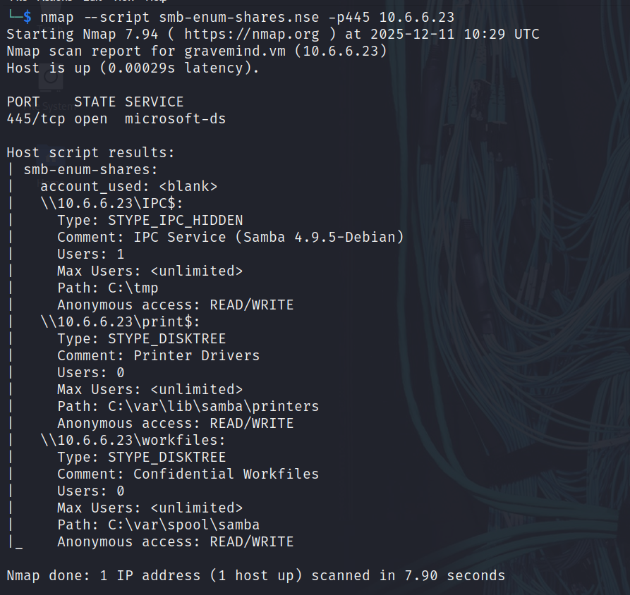

Other networking commands:

└─$ ifconfig
Determine the IP address of the Kali Ethernet interface

└─$ ip route
Determine the default gateway assigned to the Kali host using the ip route command

$ cat /etc/resolv.conf
Determine the address of the configured default DNS server by displaying the contents of the /etc/resolv.conf file. You can view the file using the cat <file name> command.

